Artificial and Computational Intelligence
Assignment-2
Group-182

Team
ANISH RADHAKRISHNAN SHOBHA KAITHASSERY | 2024ad05344 | 100%
ARUN A. PAI | 2024ac05014 | 100%
DEEPTHY.A.N | 2024ad05350 | 100%
MYTHIRAYAN B | 2024ac05276 | 100%
SAMPATH KUMAR S SHETTY | 2024ac05041 | 100%

Part-A: Gaming:
Drop Token Game with Minimax AI

- Game Overview:
  - Drop Token is a two-player strategy game played on a 5×5 grid.
  - - Players take turns dropping tokens into columns; tokens fall to the lowest available space.
  - - The goal is to align three of your tokens in a row (horizontally, vertically, or diagonally).
  - - The first player to do so wins. If the board fills with no winner, the game is a draw.

- Game Representation
  - The board is a 5×5 2D array (NumPy), where
    - 0 = empty cell
    - - 1 = human player
    - -1 = computer (AI/SYS)
  - Moves are made by selecting a column; the token drops to the lowest empty row in that column.

- AI Approach: Minimax Algorithm
  - The computer uses the Minimax algorithm (with alpha-beta pruning) to choose its moves
  - Minimax is a recursive search algorithm used in two-player, turn-based games
  - It simulates all possible moves up to a certain depth (here, depth=3), assuming both players play optimally

  - The AI tries to maximize its own score and minimize the opponent's score.
  - Alpha-beta pruning skips branches that cannot affect the final decision, making the search faster.

- Static Evaluation Function
  - When the search reaches the maximum depth or a terminal state (win/loss/draw), the board is scored using a static evaluation function
  - The evaluation function assigns points based on:
    - Win/Loss: +10000 for a win, -10000 for a loss (most important)
    - Two in a Row: +1000 for two of the player's tokens in a line (with one empty), -1000 for opponent (immediate threat)
    - One in a Row: +5 for a single token in a line (with two empty)
    - Center Control: +10 for each token in the center columns (1, 2, 3)
  - This system ensures the AI always blocks threats and pursues wins aggressively.

- Minimax Search Depth and Complexity
  - Depth: The AI looks ahead 3 moves (depth=3) for practical speed
  - Branching Factor: Up to 5 possible moves per turn (one for each column)
  - Time Complexity: O(b^d), where b=branching factor, d=depth. For b=5, d=3, that's 125 nodes per move
  - Space Complexity: O(d), due to recursion stack
  - Dynamic Complexity: The program tracks and displays the actual number of nodes explored and average depth after each game

- Key Features and Learning Outcomes
  - Human vs. AI: Play interactively against a computer that "thinks ahead"
  - Optimal Play: The AI blocks your threats and pursues its own, thanks to the evaluation function
  - Theory in Practice: See how Minimax and evaluation functions work in a real game
  - Complexity Analysis: Understand the difference between theoretical and actual search effort
  - Code Structure: Modular, with clear separation between game logic, AI, and evaluation.

- Why This Approach Works
  - Minimax ensures the AI never misses a win or fails to block a loss (within its search depth)
  - Aggressive Scoring for two-in-a-row means the AI blocks threats immediately
  - Center Control and "one-in-a-row" bonuses help the AI play strategically, not just reactively
  - Alpha-beta pruning makes the AI efficient enough for interactive play

- Educational Value
  - Demonstrates core ideas from game theory and AI
  - Shows how to design and justify a static evaluation function
  - Provides a hands-on way to explore search algorithms and complexity

In summary: This program is a complete, interactive demonstration of how AI can play a simple board game using classic search and evaluation techniques, with all key theory and practical considerations explained.

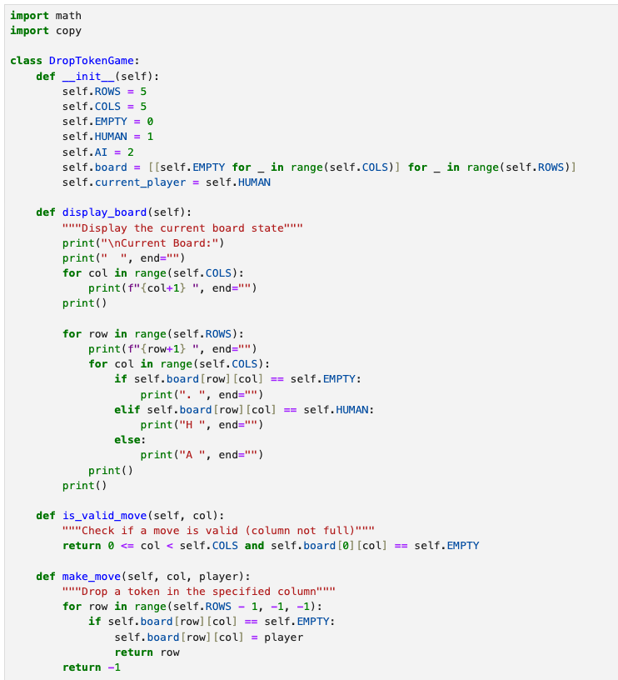

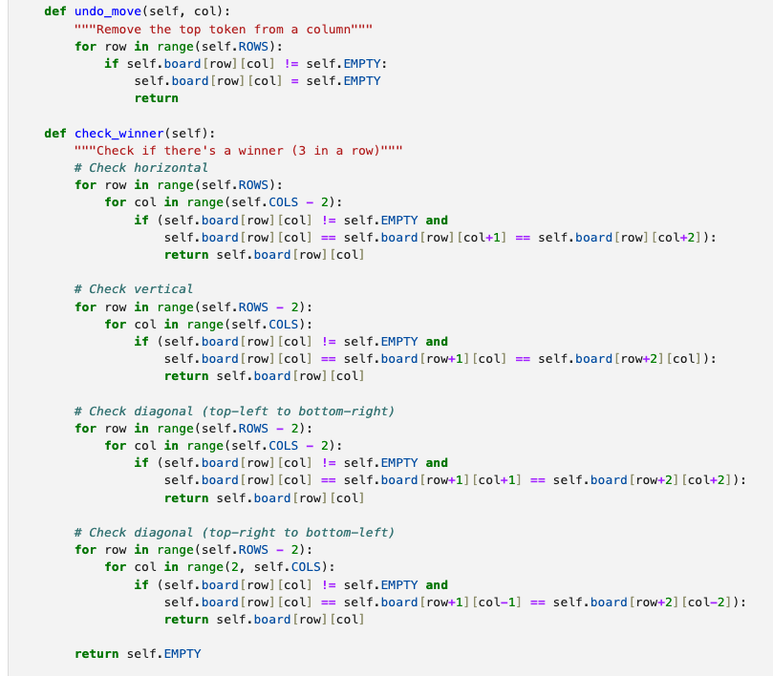

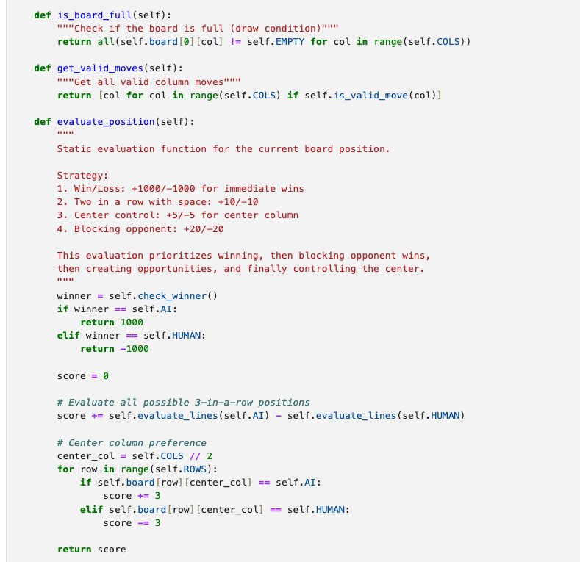
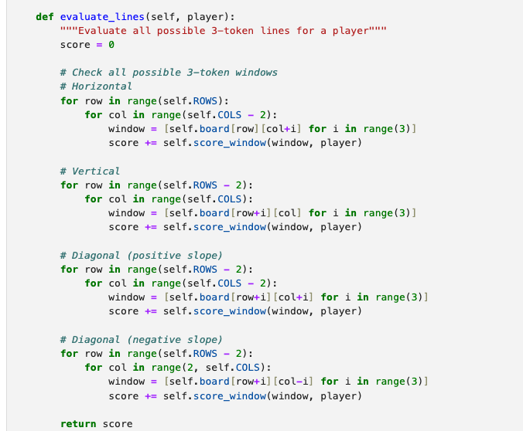
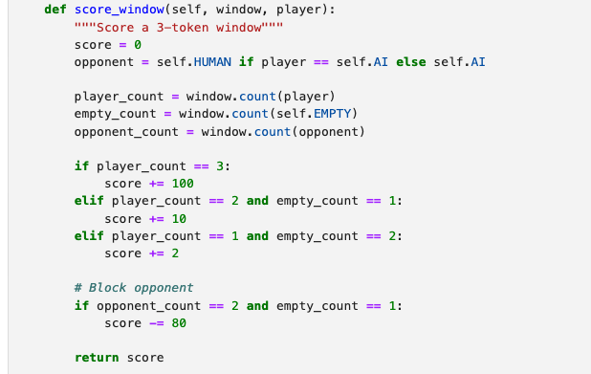
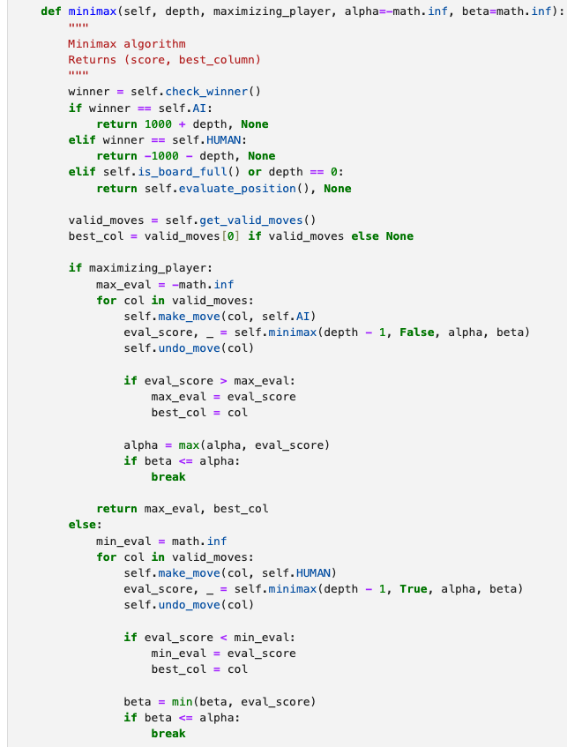
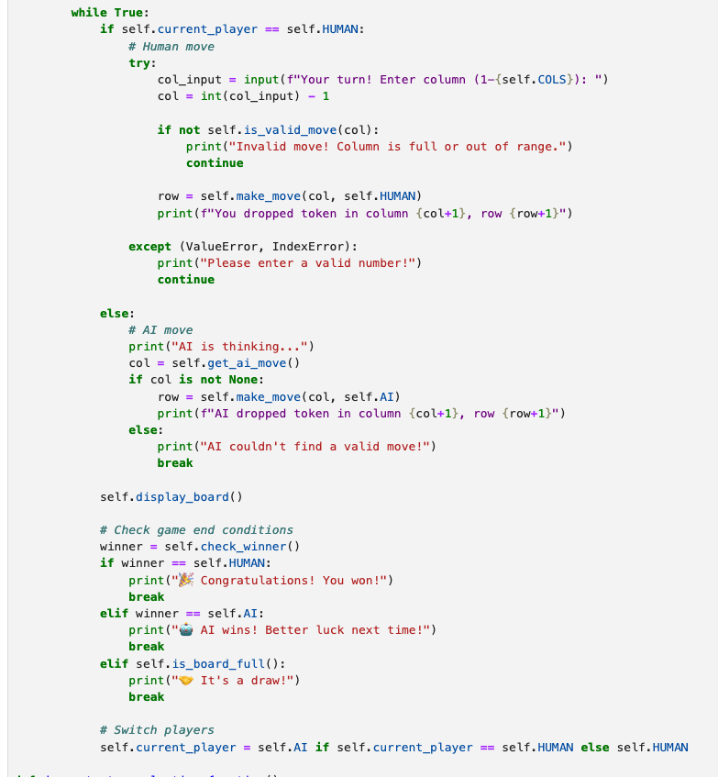

Output:

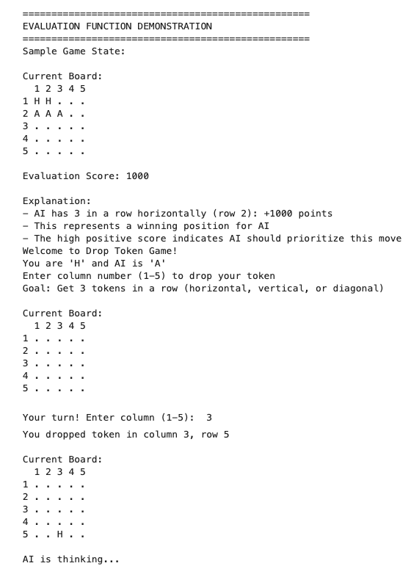
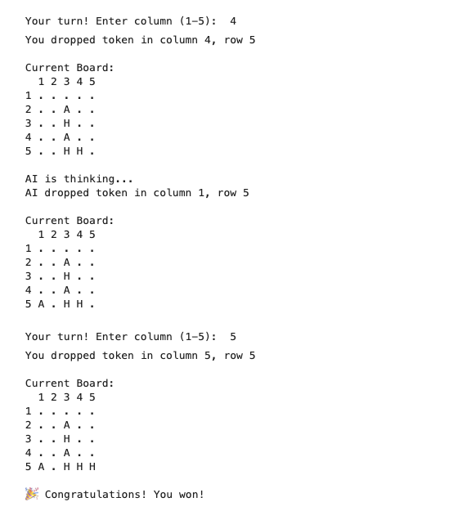

Part-B: Logic
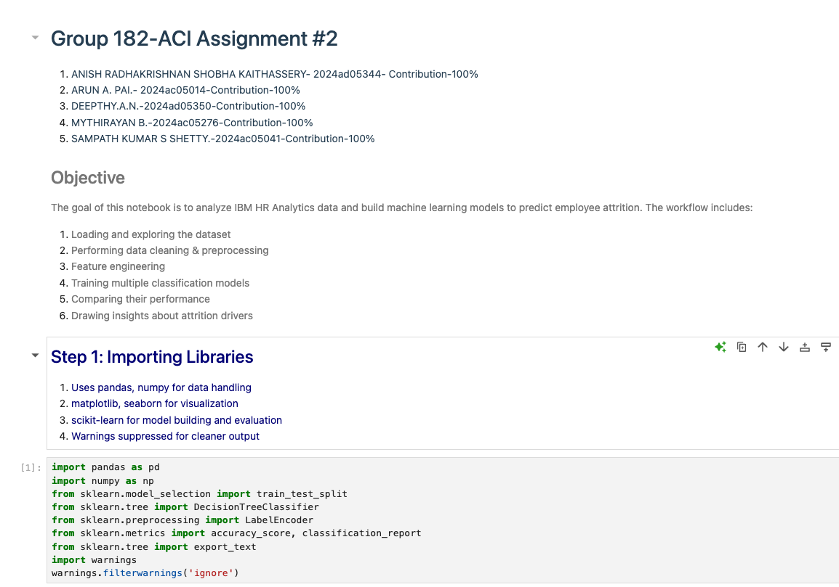
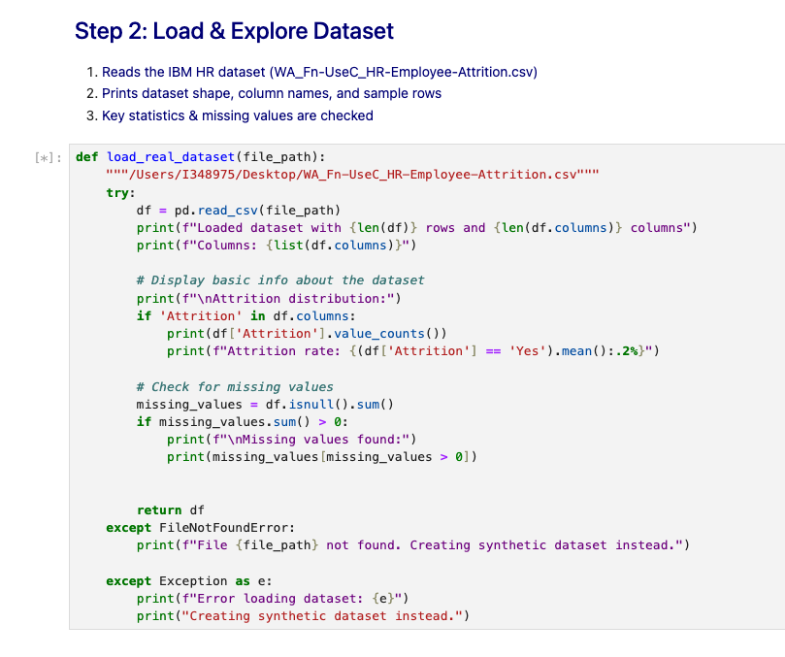
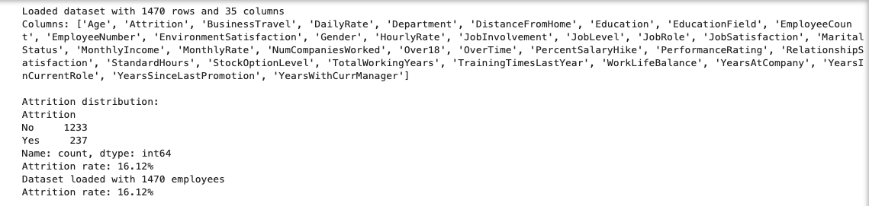
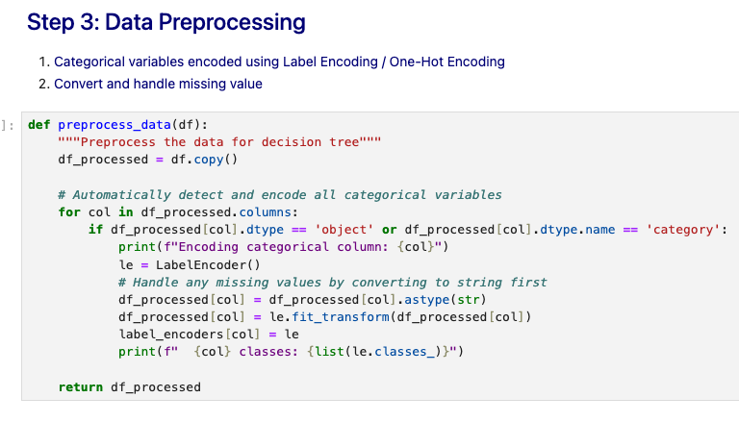
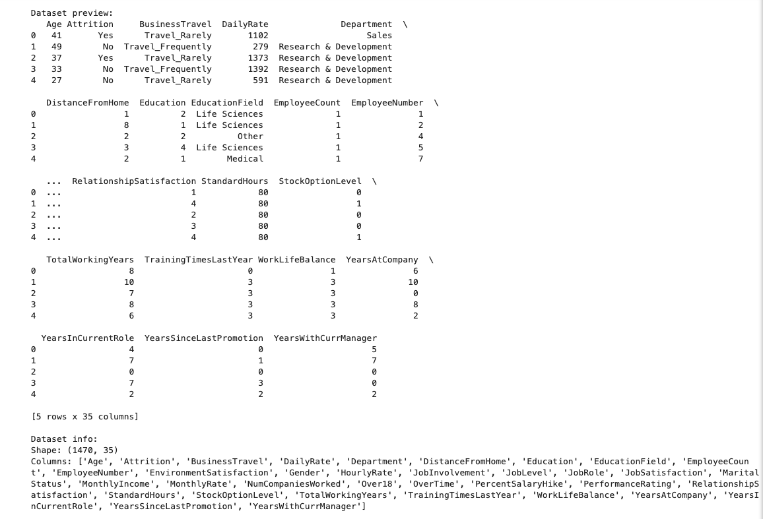
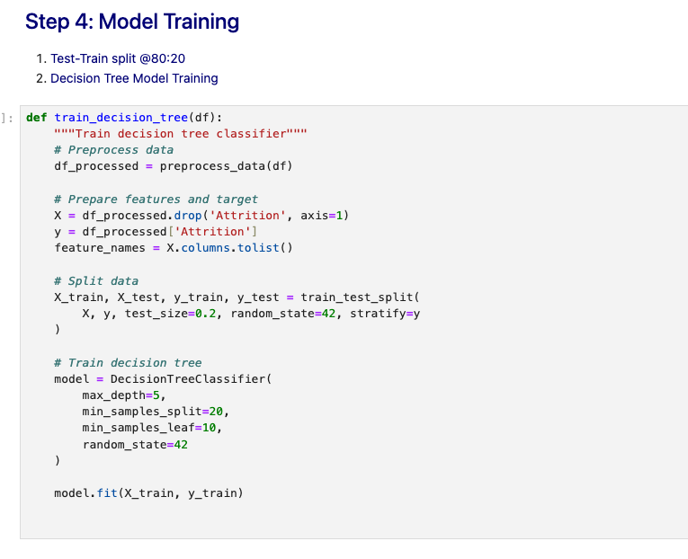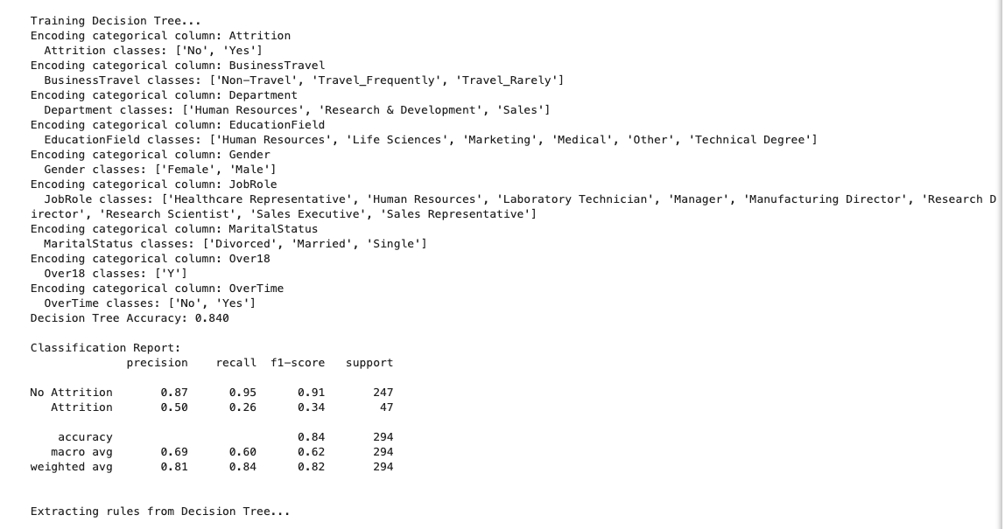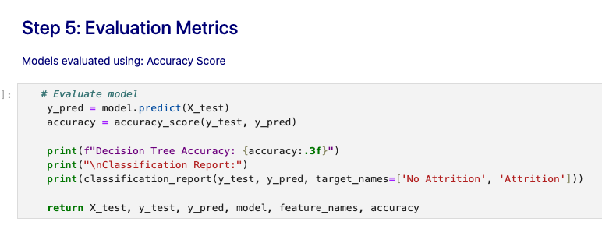


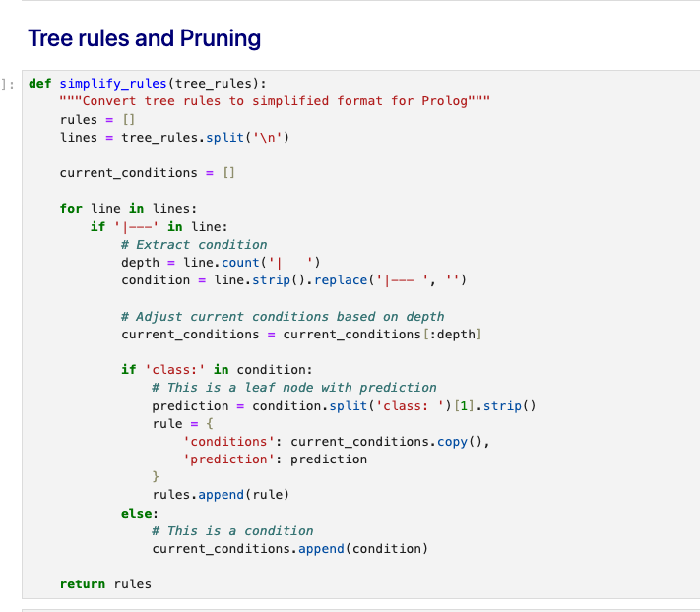

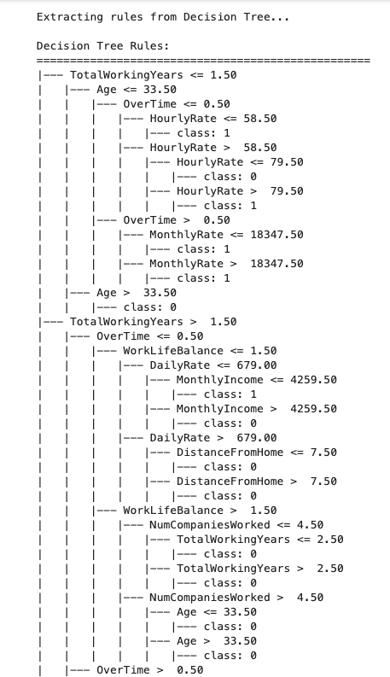
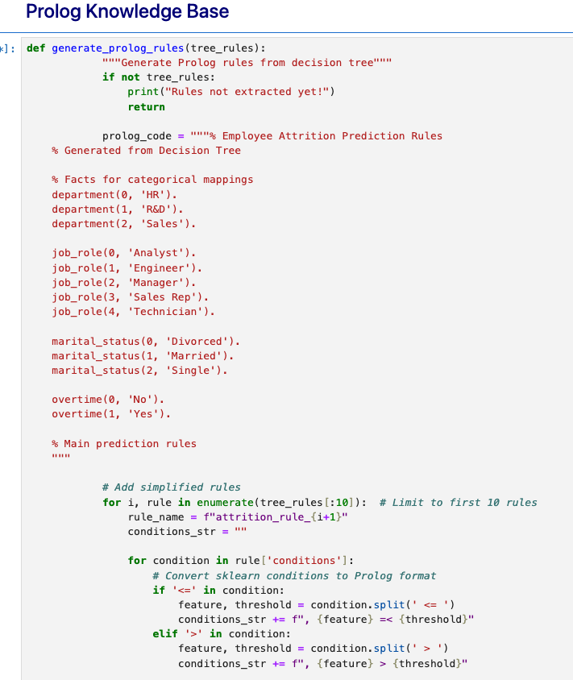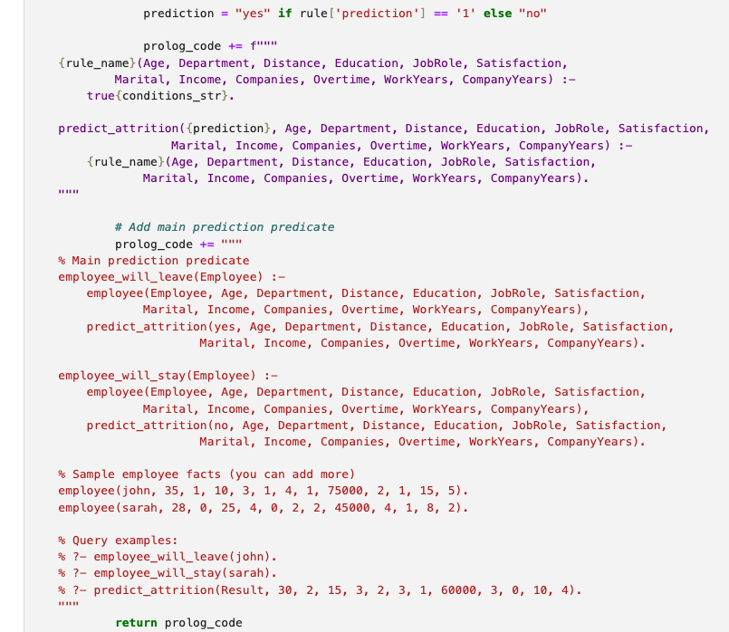

Prolog Output:

